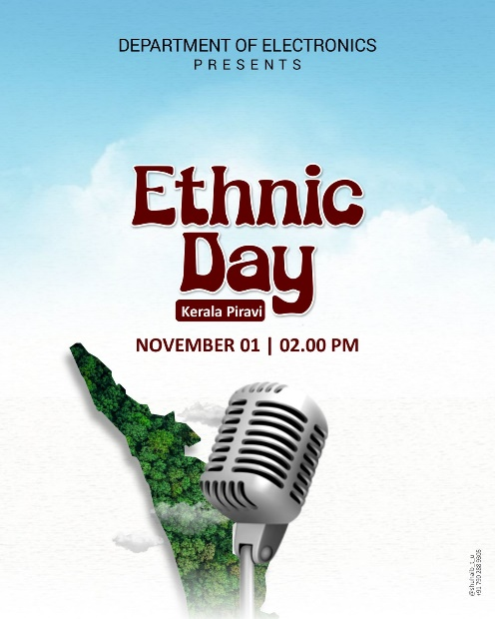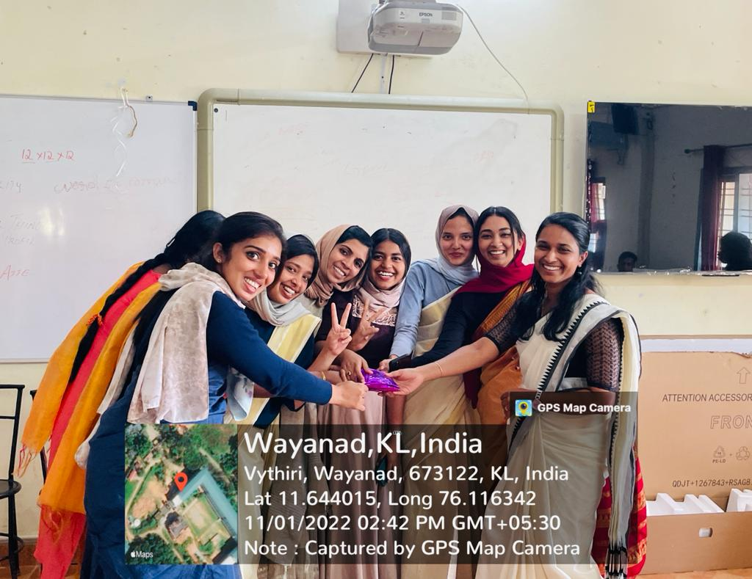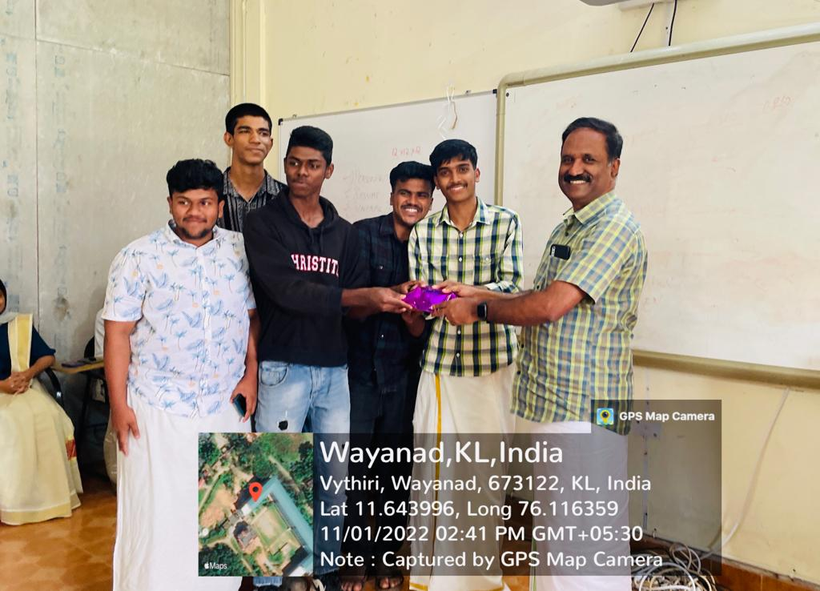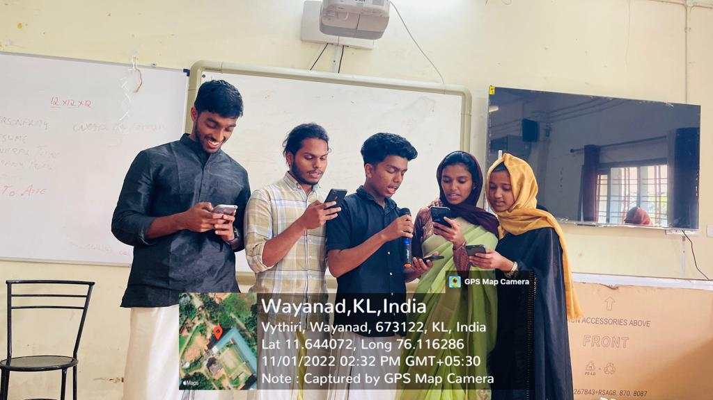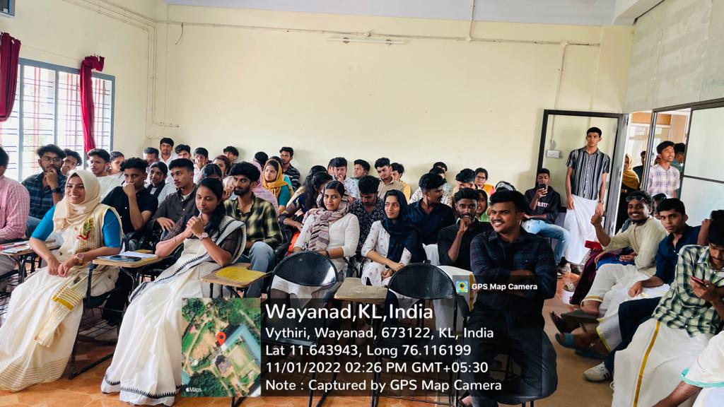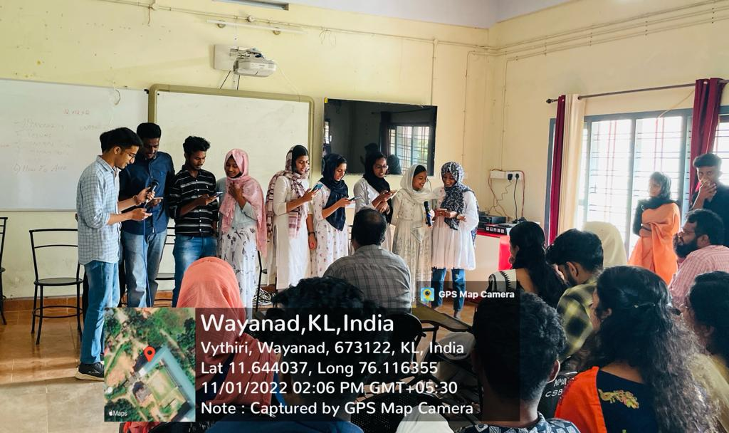

“Ethnic Day-2022” was celebrated by the department on behalf of Kerala piravi on November 1, 2022. The students and the faculties keenly took part in the celebration by wearing Kerala's traditional clothing. Also, cultural activities like batch wise song competition, dances, etc. were held.

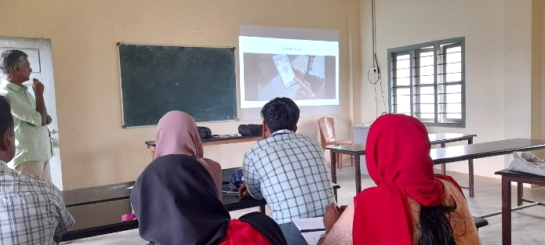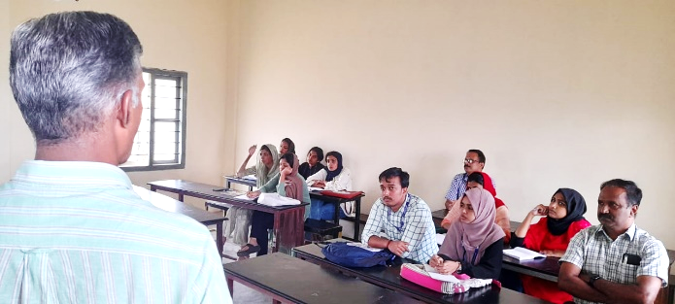
The Department of Electronics in association with IEDC conducted a workshop on “Tiny Machine Learning” at Intelligent Machine Laboratory on November 15th, 2022. The resource person was Sri. Chandra Sekharan C. P who is actively involved in several projects of governmental organizations.
The students of final year MSc Electronics attended the workshop. The students were benefitted greatly by enhancing their skills in Tiny Machine Learning and iits application in various fields including research and by industrial projects

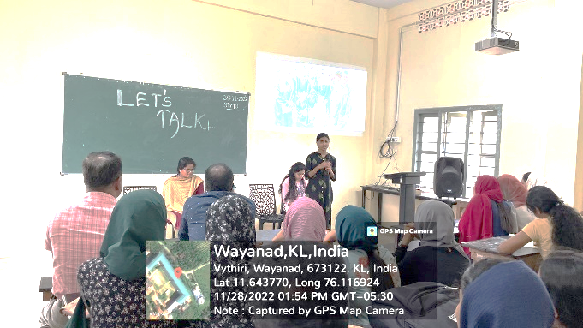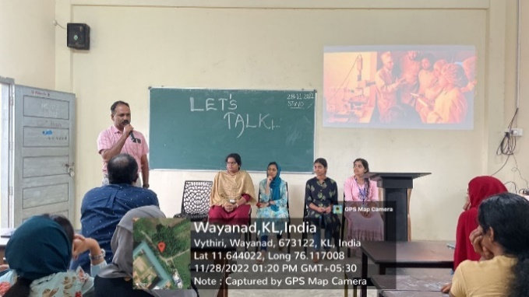

The department organized an experience-sharing session “let’s talk” to provide an opportunity for the postgraduate students – Ms.Athulya, Ms. Namitha, Ms.Anshidha and Ms. Silja to share their experiences about the hands-on internship training they attended. The internship training was the fabrication of Semiconductor devices and it was held at CSIR- Central Electronics Engineering Research Institute Pilani, Rajasthan. The session provided an opportunity for an exchange of views, experiences, and basic procedures of semiconductor fabrication. The students also got to learn about the exposure an internship will give.

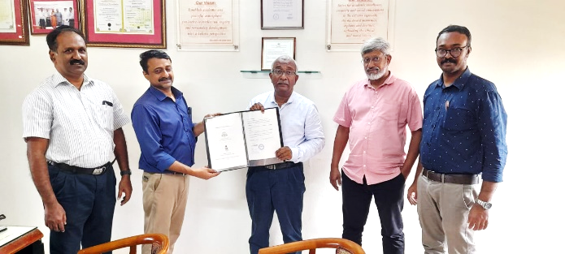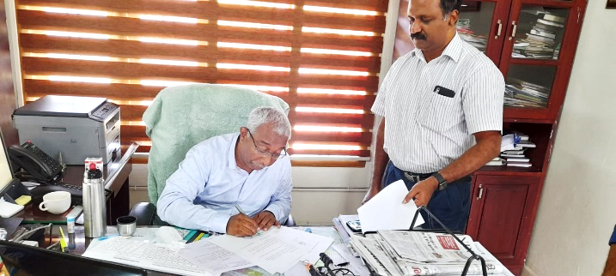
The MoU Signing Ceremony between Bismil Systems, a global engineering service provider, Prajyoti Niketan College and WMOC College was held on November 24, 2022, at the Principal’s office. The MoU was signed by Dr. Muhammed Fareed T P in the presence of Siby joseph, Abdul Rasheed and Hasannul Banna. The key objective to establish this center is to provide technical training access to advanced technologies and mentoring.

