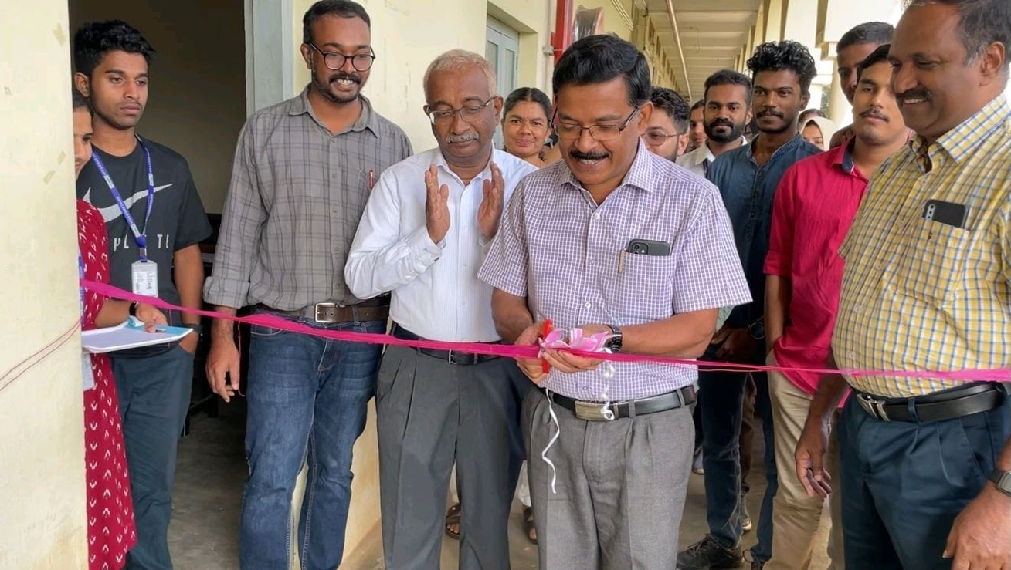
Dr. Sabu M K, Professor, Department of Computer Applications, CUSAT Inaugurated the Edison Intelligent Machines Pathway at WMO College, Muttil on January 6th, 2023. The pathway is set up in front of the Intelligent Machines Lab for displaying new and innovative projects developed by UG and PG Electronics students.

A session was conducted by the department regarding the higher studies provided at Canada and other abroad universities after graduation and post-graduation. The session was handled on January 17th, 2023 at 3.30 pm in the college dialogue hall.

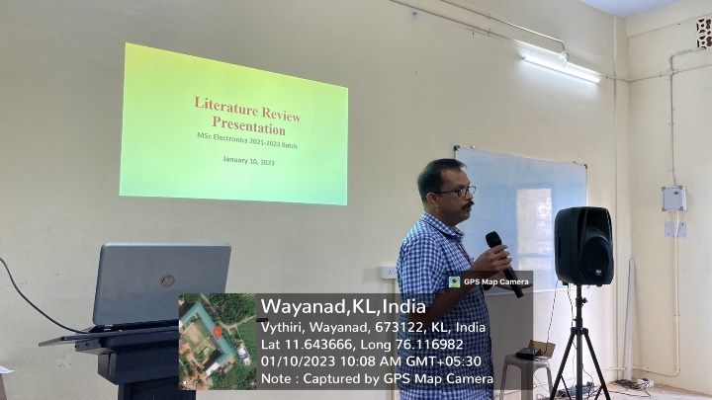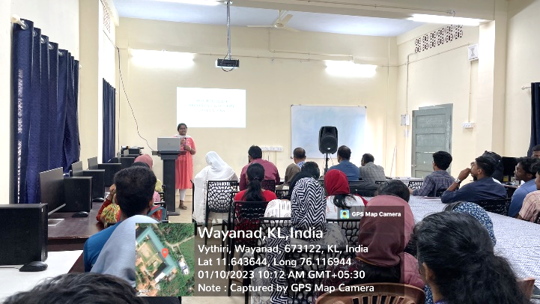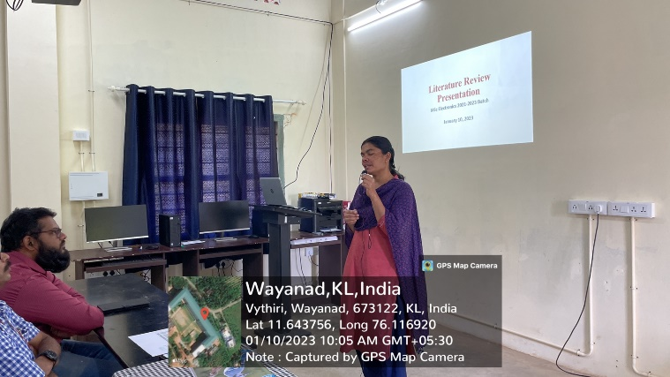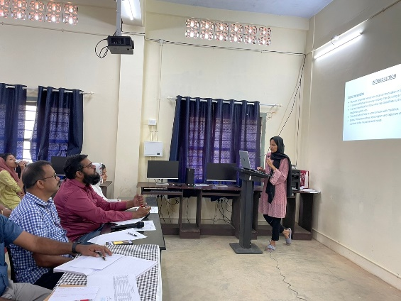

The students of 2nd year MSc Electronics presented literature review on previously published works based on different prominent topics like IOT, Robotics, Embedded System, AI, etc. The session was conducted on 10th January 2023 at Intelligence Machine Lab. Organizing literature review enhances presentation skills and helps the students to get project-based ideas.

