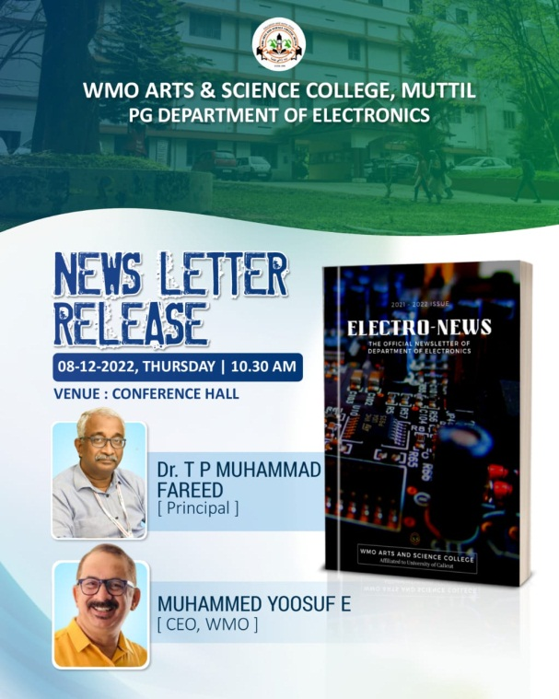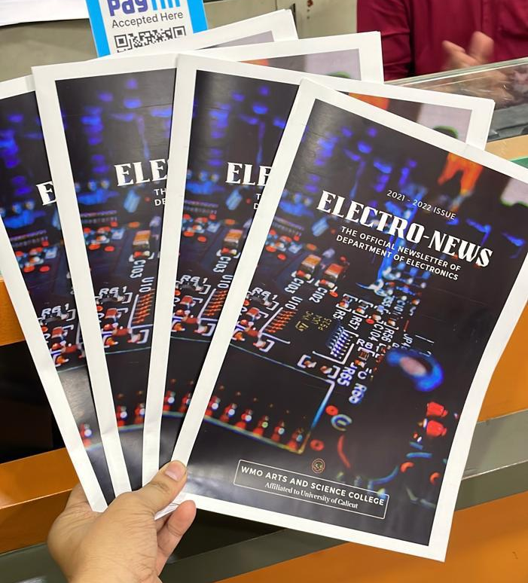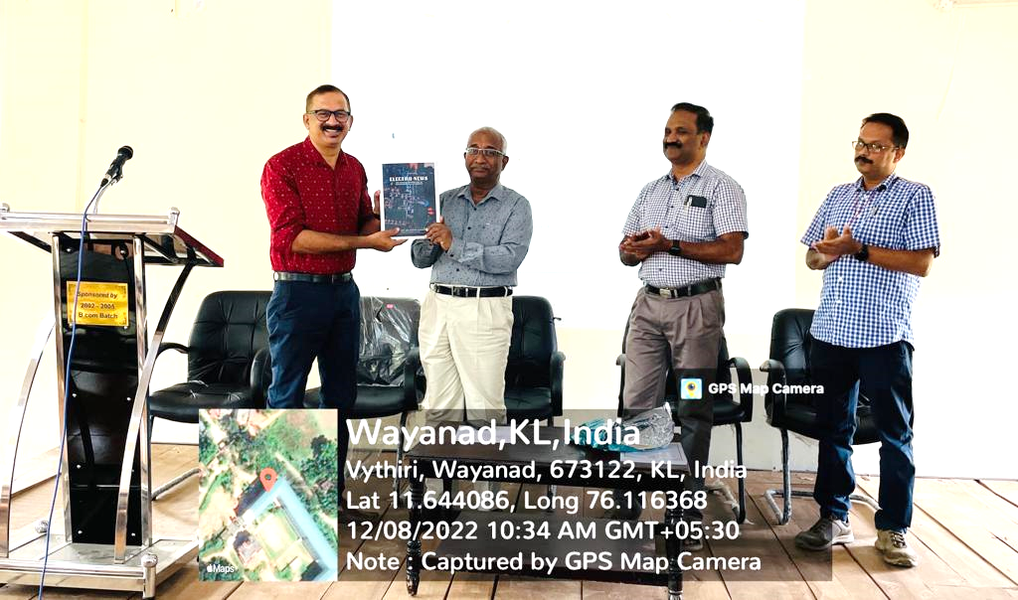

The newsletter of the Department of Electronics, ‘Electro-News 2021-22’ was released on 18th December 2022 at 10:30 am by Dr. T P Muhammed Fareed, Principal, WMO Arts and Science College, Muttil at the College Auditorium. The newsletter was presented to Mr. Muhammed Yoosuf E, CEO, of WMO, with all the faculties and students of the department as the audience. “Electro-News” provides an in-depth overview of the prior year’s activities and offers fiscal transparency to the efforts provided by the department.
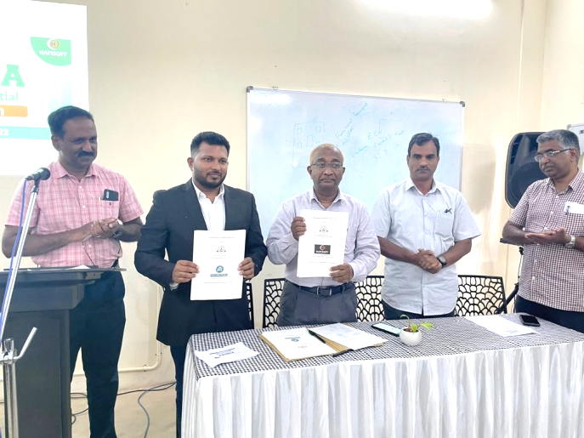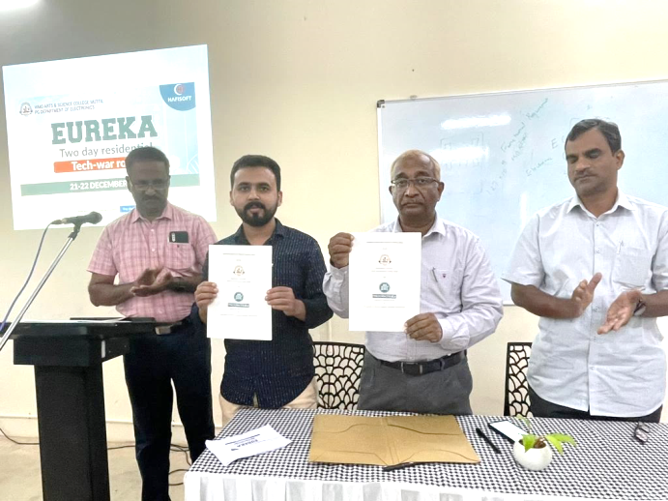

The MoUs were signed at the inauguration ceremony of the 'Eureka' residential camp on 21st December 2022. Sri. Saneesh A T (Managing Director) on behalf of Hafisoft Technologies (Infopark Campus, Cochin) and Sri Naufal (Managing Director) on behalf of Microtechlabs (Kakkavyal, Wayanad) were the signatories.
“The MoU will bring new opportunities in the expertise of internship, career opportunities, skill development, and entrepreneurship ideas for the students of BSc and MSc Electronics”- The Principal said in his keynote address.

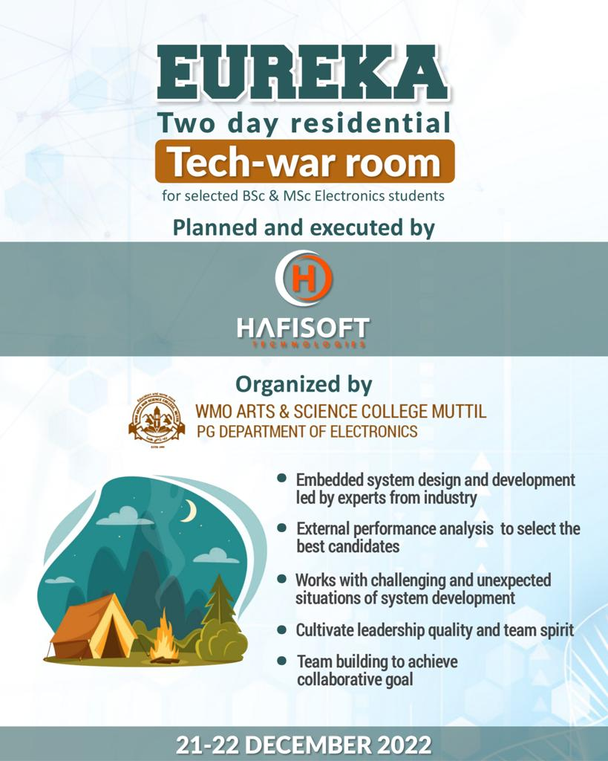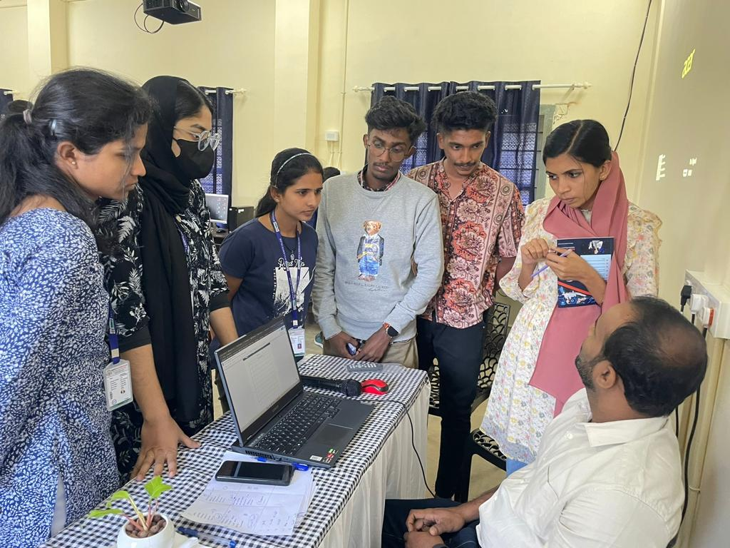
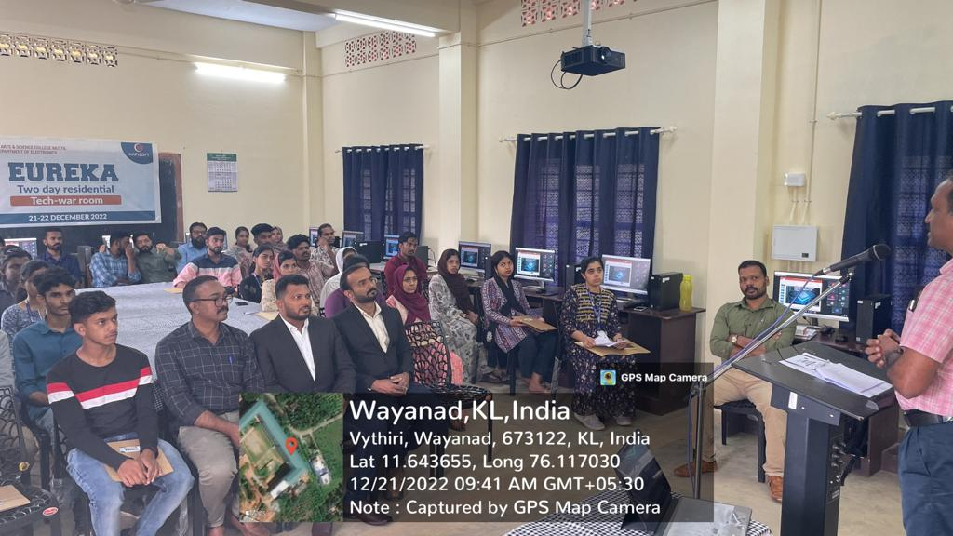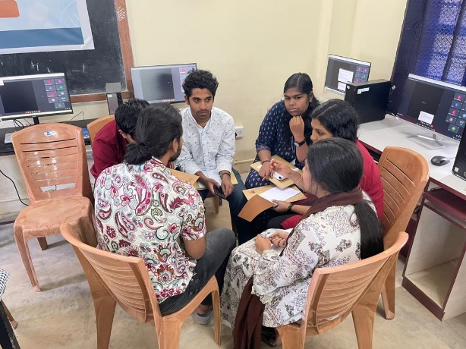
To mark the 75th anniversary of the invention of the transistor, the Department organized “Eureka”- a two-day residential ‘Tech-War Room’ in collaboration with Hafisoft Technologies. Selected UG and PG students participated in the program on the 21st and 22nd of December 2022. The participants learned about various phases of embedded system design and development. The program also enhanced essential skills like problem-solving, critical thinking, leadership, and team building.
WMO Arts and Science College Management Committee Muhammad Shah inaugurated the function and Head of Electronics Department Sri Siby Joseph, Dr. Biju KG (IQAC Coordinator), Dr. VG Paul (College Council Secretary), Shri Ashraf V (College Superintendent), Shri Shuaib TU (Student Coordinator) spoke on the occasion.

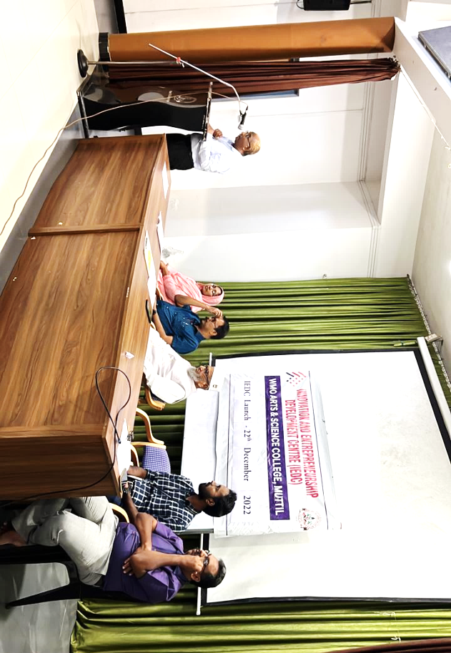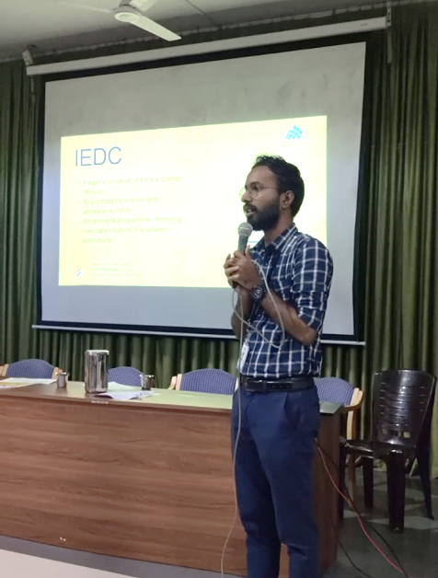
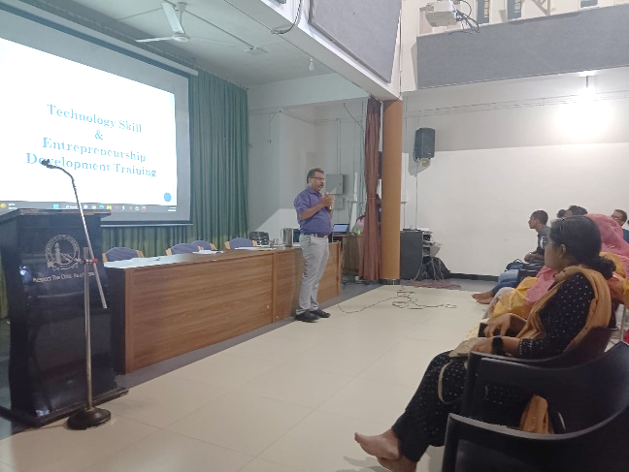
The “Innovation and Entrepreneurship Development Center (IEDC)” of WMO Arts and Science College was inaugurated by Kerala Startup Mission, IEDC Project Assistant Sri. Adarsh at WMO HRD Centre.
IEDC provides an opportunity for the students to pitch their own ideas as well as network with successful ventures. IEDC is also a platform to help budding entrepreneurs with skill development and practical knowledge. Mr. Niyaz A, the Director of Palakkad Green Technology Park, spoke about the new initiatives that are part of IEDC.
WMO Arts and Science College Principal Dr. T P Muhammad Fareed presided over the ceremony and IEDC Nodal Officer Dr. Norbert Thomas Pallath welcomed. Manager Mr. M. A. Muhammad Jamal, IEDC Assistant Nodal Officer Smt. Sabirath K and Dr. Najmudeen also spoke on the occasion.

